Dr. Laura E. Braden

Assistant Professor, Art and Culture Studies

Erasmus University

[Braden@eshcc.eur.nl](mailto:Braden@eshcc.eur.nl)

**The 1913 Armory Show, New York CityWord Count: 539**

The 1913 Armory Show was the first comprehensive exhibition of modern art to take place in the United States and served as America’s introduction to modernism in the visual arts. Formally titled the ‘International Exhibition of Modern Art’—but informally designated the ‘Armory Show’ given its location at the 69th Infantry Regiment Armory in New York City—the exhibition was organized by the Association of American Painters and Sculptors (AAPS), a small group of U.S. artists, with the goal of offering a survey of modern art from Impressionism to Cubism and to spur the establishment of modern art in the United States. The exhibition ran for four weeks (17th February - 15th March) and offered more than 1,300 works by 308 artists who hailed from 25 nations (though US artists composed more than half of this total). Fifty-three of the artists were women, a few of whom exhibited work alongside their husbands. Other Armory Show artists are among the most well-known names in current art history, including Mary Cassatt, Paul Cézanne, Marcel Duchamp, and Pablo Picasso. Conservative estimates put attendance for the Armory Show at 3,214 visitors a day, or a total of 90,000 visitors in the four weeks of the Armory’s run in New York, though some estimate the overall attendance closer to a quarter of a million.

The impact of the Armory Show was both immediate and lasting. Attendees included former U.S. President Theodore Roosevelt, who wrote a somewhat favorable, if not bemused, critique of the exhibition. While much critical notice of the Armory Show was censorious, the exhibition nevertheless produced considerable interest. After the New York premier, a much smaller version (about 300 works) of the Armory Show featuring only European artists toured the U.S., stopping in Chicago, where approximately 188,000 people attended, with some attendees vigorously protesting the controversial avant-garde works, including paintings burned in effigy. The Armory Show’s tour ended in Boston, where the show was largely boycotted by society afraid to be associated with the new art.

The Armory Show impacted visual arts in America both aesthetically and materially. The formation of several of the nation’s most important modern art collections have been directly linked to the Armory Show. Collections first influenced by visits to the Armory include the Lillie Bliss collection, which became the core of the Museum of Modern Art in New York, the Arensberg collection, which became the Louise and Walter Arensberg Collection of the Philadelphia Museum of Art, Katherine Drier’s Collection of the Société Anonyme, now at Yale University, and the Eddy collection, which became the Chicago Art Institute’s Arthur Jerome Eddy Memorial Collection. Additionally, after the success of the Armory, new galleries, publications, associations, and exhibitions dedicated to modern art proliferated. In 1994, an annual art fair named in honor of the 1913 Armory Show was initiated. This current “Armory Show,” held along the Hudson River in Manhattan, is a leading art fair in New York, as well as internationally.

**References and further reading**

Association of American Painters and Sculptors. “Catalogue of the *International Exhibition of Modern Art*,” New York, February 17-March 15, 1913.

Kuhn, W. (1938). *The Story of the Armory Show*. New York.

Staples, S. (2001). *As Avant-Garde as the Rest of Them: An Introduction to the Armory Show*. <http://xroads.virginia.edu/~museum/armory/intro.html>

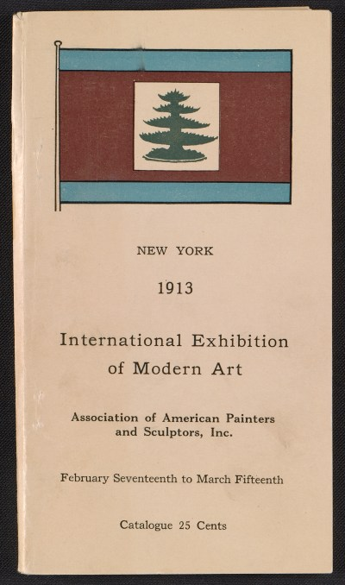

Catalogue of the International Exhibition of Modern Art in New York, 1913. Walt Kuhn, Kuhn family papers, and Armory Show records, Archives of American Art, Smithsonian Institution.

Physical Details: Exhibition catalog : 112 p. : ill. ; 20 x 11 cm.

Creator: Association of American Painters and Sculptors (New York, N.Y.)

Forms part of: Walt Kuhn, Kuhn family papers, and Armory Show records, 1859-1978, bulk 1900-1949

Rights Statement: U.S. public domain

<http://www.aaa.si.edu/collections/images/detail/catalogue-international-exhibition-modern-art-new-york-481>